**IS410 | Group 7 | Deliverable 2 | UMBC - Fall 2024**

Group Members - Russell Poon, Hudson Pae, Willis Crosby, Gabriel Dennis

**ERD**

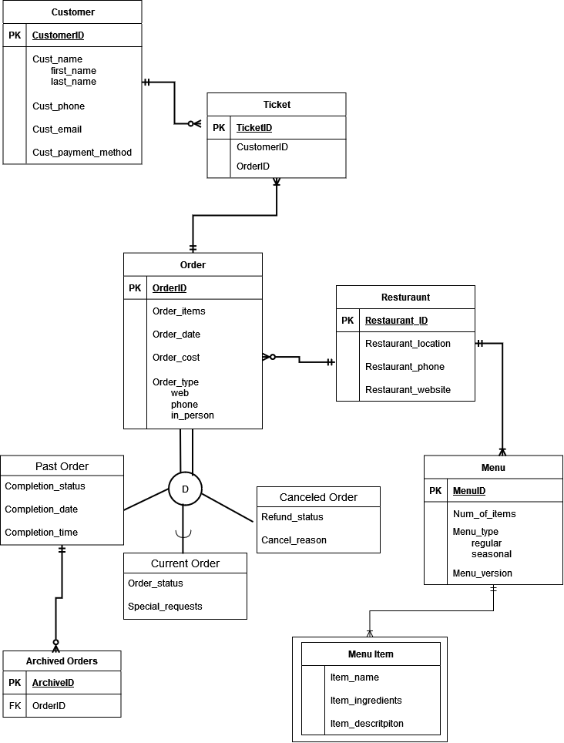

**Entities**

Possible Entities: Customer Accounts, Inventory

| **Entities** | **Strong** | **Weak** | **Transactional** | **Supertype** | **Subtype** |
| --- | --- | --- | --- | --- | --- |
| **Customer** | X |  |  |  |  |
| **Order** | X |  | X | X |  |
| **Ticket** |  | X |  |  |  |
| **Restaurant** | X |  |  |  |  |
| **Archive** | X |  |  |  |  |
| **Menu** | X |  |  |  |  |
| **Menu Items** |  | X |  |  |  |
| **Past Order** |  |  |  |  | X |
| **Current Order** |  |  |  |  | X |
| **Canceled Order** |  |  |  |  | X |

Strong Entities

* Customer
* Restaurant
* Menu
* Archive

Weak Entities

* Menu Items (Strong Entity - Restaurant)
* Ticket (Associative Entity)

Transactional Entities

* Order(order number, menu items)- (Classification - can be a past order(archive ID), current order(archive ID, order status), or a canceled order(archive ID, refund number)

Supertypes

* Order

Subtypes

Order Subtypes

* Past Orders
* Current Orders
* Canceled Orders

**Relationships**

| **Customer** | **Definition of Relationship** |
| --- | --- |
| Customer_ID  Cust_name  Cust_phone  Cust_email  Cust_payment_method | **Primary Key**  Composite  Single  Single  Single |

| **Restaurant** | **Definition of Relationship** |
| --- | --- |
| Restaurant_ID  Restaurant_location  Restaurant_phone  Restaurant_website | **Primary Key**  Composite  Single  Single |

| **Menu Items** | **Definition of Relationship** |
| --- | --- |
| Item_Name  Item_Descritpiton  Item_Ingredients | Single  Composite  Multi-Valued |

| **Menu** | **Definition of Relationship** |
| --- | --- |
| Menu_ID  Number_of_items  Menu_type  Menu_Version | **Primary Key**  Single  Multi-Valued  Single |

| **Archive** | **Definition of Relationship** |
| --- | --- |
| Archive_ID  Order_ID | **Primary Key**  **Foreign Key** |

| **Order** | **Definition of Relationship** |
| --- | --- |
| Order_ID  Order_Items  Order_date  Order_cost  Order_type | **Primary Key**  Multi-Valued  Single  Single  Multi-Valued |

| **Past Order** | **Definition of Relationship** |
| --- | --- |
| Completion_status  Completion_date  Completion_time | Single  Single  Single |

| **Current Order** | **Definition of Relationship** |
| --- | --- |
| Order_status  Special_request | Single  Composite |

| **Canceled Order** | **Definition of Relationship** |
| --- | --- |
| Refund_status  Cancel_reason | Single  Multi-value |

| **Ticket** | **Definition of Relationship** |
| --- | --- |
| Ticket_ID  Customer_ID  Order_ID | **Primary Key**  **Foreign Key**  **Foreign Key** |

**Attributes**

Customer:

* Cust_ID: Customer ID; key identifier (primary key); required; simple; single-valued.
* Cust_name: Customer name; key identifier; required; composite; single-valued.
* Cust_phone: Customer phone number; required; simple; single-valued.
* Cust_email: Customer email address: optional; simple; single-valued.
* Cust_payment_method: Customer payment method; required; simple; single-valued.

Restaurant:

* Restuarant_ID: Restaurant ID; key identifier (primary key); required; simple; single-valued.
* Restaurant_location: Restaurant location; required; composite; single-valued; state and city can be derived from zip.
* Restaurant_phone: Restaurant phone number; required; simple; single-valued.
* Restaurant_website: Restaurant website; required; simple; single-valued.

Menu Items:

* Item_name: Item name; required; simple; single-valued.
* Item_description: Item description; optional; composite; single-valued.
* Item_ingredients: Item ingredients; optional; simple; multi-valued

Menu:

* Menu_ID: Menu ID; key identifier (primary key); required; simple; single-valued.
* Number_of_items: Number of items; required; simple; single-valued.
* Menu_type: Menu type; required; simple; multi-valued.
* Menu_version: Menu version; required; simple; single-valued.

Archive:

* Archive_ID: Archive ID; key identifier (primary key).
* Order_ID: Order ID: key identifier (foreign key).

Order:

* Order_ID: Order ID; key identifier (primary key); required; simple; single-valued.
* Order_items: Order items; required; simple; multi-valued.
* Order_date: Order date; required; simple; single-valued.
* Order_cost: Order cost; required; simple; single-valued.
* Order_type: Order type; required; simple; multi-valued.

Past Order:

* Completion_status: Completion status; required; simple; single-valued.
* Completion_date: Completion date; required; simple; single-valued.
* Completion_time: Completion time; required; simple; single-valued.

Current Order:

* Order_status: Order status; required; simple; single-valued.
* Special_request: Special request; optional; composite; single-valued.

Canceled Order:

* Refund_status: Refund status; required; simple; single-valued.
* Cancel_reason: Cancel reason; required; simple; multi-valued.

Ticket:

* Ticket_ID: Ticket ID; key identifier (primary key); required; simple; single-valued.
* Customer_ID: Customer ID; key identifier (foreign key).
* Order_ID: Order ID; key identifier (foreign key).